FURTHER EDUCATION AND TRAINING CERTIFICATE: INFORMATION TECHNOLOGY: SYSTEMS DEVELOPMENT
ID 78965 LEVEL 4 – CREDITS 165
US ID : 119471
LEARNER GUIDE
USE LANGUAGE AND COMMUNICATION IN OCCUPATIONAL LEARNING PROGRAMMES



Learner Information:

Details | Please Complete this Section
Name & Surname:
Organisation:
Unit/Dept:
Facilitator Name:
Date Started:
Date of Completion:

Copyright
All rights reserved. The copyright of this document, its previous editions and any annexures thereto, is protected and expressly reserved. No part of this document may be reproduced, stored in a retrievable system, or transmitted, in any form or by any means, electronic, mechanical, photocopying, recording or otherwise without the prior permission.

Key to Icons
The following icons may be used in this Learner Guide to indicate specific functions:
  Books | This icon means that other books are available for further information on a particular topic/subject.
  References | This icon refers to any examples, handouts, checklists, etc…
  Important | This icon represents important information related to a specific topic or section of the guide.
  Activities | This icon helps you to be prepared for the learning to follow or assist you to demonstrate understanding of module content. Shows transference of knowledge and skill.
  Exercises | This icon represents any exercise to be completed on a specific topic at home by you or in a group.
  Tasks/Projects | An important aspect of the assessment process is proof of competence. This can be achieved by observation or a portfolio of evidence should be submitted in this regard.
  Workplace Activities | An important aspect of learning is through workplace experience. Activities with this icon can only be completed once a LEARNER is in the workplace
  Tips | This icon indicates practical tips you can adopt in the future.
  Notes | This icon represents important notes you must remember as part of the learning process.

Learner Guide Introduction
About the Learner Guide… | This Learner Guide provides a comprehensive overview of the USE LANGUAGE AND COMMUNICATION IN OCCUPATIONAL LEARNING PROGRAMMES, and forms part of a series of Learner Guides that have been developed for The series of Learner Guides are conceptualized in modular’s format and developed for. They are designed to improve the skills and knowledge of learners, and thus enabling them to effectively and efficiently complete specific tasks.  Learners are required to attend training workshops as a group or as specified by their organization. These workshops are presented in modules, and conducted by a qualified facilitator.
Purpose | The purpose of this Learner Guide is to provide learners with the necessary knowledge related to USE LANGUAGE AND COMMUNICATION IN OCCUPATIONAL LEARNING PROGRAMMES
Outcomes | At the end of this module, you will be able to:  - Accommodate audience and context needs in oral/signed communication  - Interpret and use information from texts  - Use language and communication in occupational learning programmes  - Write/present/sign texts for a range of communicative contexts  - Engage in sustained oral/signed communication and evaluate spoken/signed texts  - Write/present/sign for a wide range of contexts  - Read/view, analyse and respond to a variety of texts  - Use language and communication in occupational learning programmes
Assessment Criteria | The only way to establish whether a learner is competent and has accomplished the Learning Outcomes is through an assessment process.  Assessment involves collecting and interpreting evidence about the learner’s ability to perform a task.  This guide may include assessments in the form of activities, assignments, tasks or projects, as well as workplace practical tasks. Learners are required to perform tasks on the job to collect enough and appropriate evidence for their portfolio of evidence, proof signed by their supervisor that the tasks were performed successfully.
To qualify | To qualify and receive credits towards the learning program, a registered assessor will conduct an evaluation and assessment of the learner’s portfolio of evidence and competency
Range of Learning | This describes the situation and circumstance in which competence must be demonstrated and the parameters in which learners operate
Responsibility | The responsibility of learning rest with the learner, so:  - Be proactive and ask questions,  - Seek assistance and help from your facilitators, if required.

Learning Unit1
USE LANGUAGE AND COMMUNICATION IN OCCUPATIONAL LEARNING PROGRAMMES

UNIT STANDARD NUMBER : 119471
LEVEL ON THE NQF : 4
CREDITS : 5
FIELD : Communication Studies and Language
SUB FIELD : Language

PURPOSE: | The purpose of this unit standard is to facilitate learning and to ensure that learners are able to cope with learning in the context of learnerships, skills programmes, and other learning programmes. Many adult learners in the FET band have not been in a learning situation for a long time, and need learning and study strategies and skills to enable successful progression.  Learners competent at this level will be able to deal with learning materials, to access and use useful resources, to seek clarification and help when necessary, and apply a range of learning strategies. They do this with an understanding of the features and processes of the workplace and occupations to which their learning programme refer.  - Access and use suitable learning resources  - Use learning strategies  - Manage occupational learning programme materials  - Conduct basic research, analyse and present findings  - Function in a team  - Reflect on how characteristics of the workplace and occupational context affect learning
LEARNING ASSUMED TO BE IN PLACE:
The credit calculation is based on the assumption that learners are already competent in terms of the full spectrum of language knowledge and communication skills laid down in the Revised National Curriculum Statements and unit standards up to NQF level 2.

SESSION 1.

ACCESS, USE AND MANAGE SUITABLE LEARNING RESOURCES.
Learning Outcomes
- Relevant learning resources are identified.
- Learning resources are used effectively and managed through appropriate selection and cross-referencing of information and acknowledgement of sources.

1. Introduction
In the modern times we live in, we have access to a multitude of learning resources. What are learning resources? They are sources (the point or place from which something originates) of information from which one can learn. The many different types of resources means that we need to have a goal (to know what we want/need), and also the ability to access/use the resources available to us.
2. Relevant learning resources are identified
It is very important that the learning resources you use are relevant to your goal (what you need/want to achieve). You need to know where to find the different learning resources:
Resource centers:- These are 'places' where you will find various types of learning resources,

Libraries - where you will find mostly printed information, but also some visual information; internet - where you will find a wealth of electronic information; archives - where records (including data) are kept; etc.


Once you have located the resource centre/s, you need to be able to identify the actual learning resources, so that you can select a relevant one:
- General texts
These are usually in the form of books, but can also be reports, letters, memo's, etc.

- Printed and visual media

Firstly, we need to know that media is the means of communication that reaches large numbers of people
Printed media is mainly newspapers and magazines. Visual media is television and films/videos. We also have audio media - the radio - but this is not an ideal learning resource, because it is not easy to retain information that you have only heard.

- Internet
This is becoming an increasingly valuable learning resource, as the sky is the limit regarding the information available on the internet. It is, however, of vital importance to know exactly what it is you need to find out/learn, as it is very easy to stray off the topic/subject due to the vast array of information.

- Other people
Here we have a learning resource that is often underestimated because of its simplicity. The most important factor regarding this resource, is that the person/people must be knowledgeable on the specific topic/subject. A wealth of information lies hidden within experienced people, who are often only too happy to share it with interested parties.
3. Use learning resources effectively through appropriate selection of information and acknowledgement of sources.
As mentioned earlier, before you can start using information to learn from, it is of great importance to know what your goal is - know what information you need to know. Once you have identified what it is that you have to know, you need to be able to select information appropriately - you need to choose the correct information that will enable you to achieve your goal. Make sure you request or choose material that contains information that will satisfy your need. The choice of inappropriate information will only confuse you and make your goal so much more difficult to achieve.
After having used the selected material to gain the necessary information, it is of vital importance to cite/give credit to the sources you used. Failure to do so results in plagiarism. Plagiarism is the unauthorized use or close imitation of the language and thoughts of another author and the representation of them as one's own original work, and is punishable by law.
The acknowledgement of your sources should be in the form of a bibliography at the end of your communication. This credit also serves as proof that you have done research, which will in turn increase your credibility.

SESSION 2.

FORMULATE AND USE LEARNING STRATEGIES.
Learning Outcomes
- Learning strategies are formulated by selection of specific tried techniques.
- Information is summarized and used in the learning process.
- Answers pertaining to relevant questions are synthesised and contextualised.
- Texts are read/view for detail, interpreted, analysed and synthesised for a given context.
- Verbal interaction is interpreted, analysed and synthesised for a given context.
- Learning takes place through communicating with others in groups or as individuals.

1. Introduction
Now that you have the correct learning resources that contain the necessary information to help you achieve your goal, it is necessary to use the correct learning strategies to make this possible. Different situations require different strategies to help you extract the appropriate information. In this learning unit we will look at various strategies that will enable this.
2. Summaries
A summary is a short version of a longer piece of writing. The summary should contain all the important parts of the original, but expresses them in a shorter space.
- Summarising is a very useful skill when gathering information.
- The summary should be written in your own words. It's more useful to re-write the contents, rather than copying out parts of the original.
- Read the original quickly, and try to understand its main subject.
- Then you will need to read it again to understand it in more detail.
- Underline or make a note of the main points. Use a highlighter if this helps. Look up any words or ideas you don't know. You need to understand the sentences and how they relate to each other.
- Work through the writing to spot the main sections or arguments. These might be shown as paragraphs.
Remember that the purpose of a paragraph is that it deals with just one issue or topic. Draw up a list of the topics - or make a diagram. A simple picture of boxes or a spider diagram can often be helpful.
Write a one or two-sentence version of each section. Just express the main point.
Leave out any examples.
- Write a sentence which states the main idea of the original writing.
- Use this as the starting point. Then write a paragraph which combines all the points
- you have made.
- The final summary should capture the main point of the original.
Remember that it should be in your own words. You re-create the meaning of the original in a way which makes sense for you.
Original
At a typical football match we are likely to see players committing deliberate fouls, often behind the referee's back. They might try to take a throw-in or a free kick from an incorrect but more advantageous position in defiance of the clearly stated rules of the game. They sometimes challenge the rulings of the referee or linesmen in an offensive way, which often deserves punishment or even sending off. No wonder this leads spectators to fight amongst themselves, damage stadiums, or take the law into their own hands by invading the pitch in the hope of affecting the outcome of the match. [100 words]
Summary
Unsporting behaviour by footballers may cause hooliganism
among spectators. [9 words]

As can be seen, this strategy makes it possible to refer back to the information, without the cumbersome task of going through all the information that was gathered.
3. Group activities
Group activities are often very useful, because it looks at something from a much broader perspective than when it is the thoughts/ ideas/ bias/ short-sightedness/ etc. of just one person.
Here we will be looking at
♦ brainstorming
♦ group analysis
♦ peer and self-assessment mind maps
♦ note taking
♦ Memorising
♦ key words and
♦ underlining.
3.1 Brainstorming
Brainstorming is when different people who have a vested interest in the matter, get together and share thoughts and ideas on a specific topic. These thoughts and ideas should not be pre-meditated.
The following guidelines apply to ensure a successful session:

- write the objective - what you want to accomplish. Distribute it to the attendees, and
- post it for all to see during the session.
- invite a mix of contributors/participants. Split large groups into teams to compete.
- set a time limit :- 30 mins - 4 hrs
- announce the objective and explain the rules :-

⇒ weird, wild, wacky and off-the-wall ideas are welcome -> negativity is not
⇒ build on ideas -> don't shoot them down
⇒ no interruptions from outside allowed (that includes cell phones!)
⇒ take a short break every hour
♦ capture all ideas as they flow from the group.
♦ evaluate the ideas, selecting the best.
♦ assign next steps.
3.2 Group analysis
Group analysis combines psychoanalytic insights with an understanding of social and interpersonal functioning. There is an interest, in group analysis, on the relationship between the individual group member and the rest of the group, resulting in a strengthening of both, and a better integration of the individual with his or her group. Group members are supported, through shared experience and joint exploration within the group, in coming to a healthier understanding of their situation. Problems are seen at the level of the group, organisation or institutional system; not solely in the individual.
Problems within are recast as obstacles without. The way in which the group functions is central to this. Democracy and co-operation are the pillars through which group-mediated solutions to problems can flow in ways that are enduring. It is based on the principles developed by S.H. Foulkes in the 1940's and is rooted in psychoanalysis and the social sciences.
3.3 Peer and self-assessment mind maps
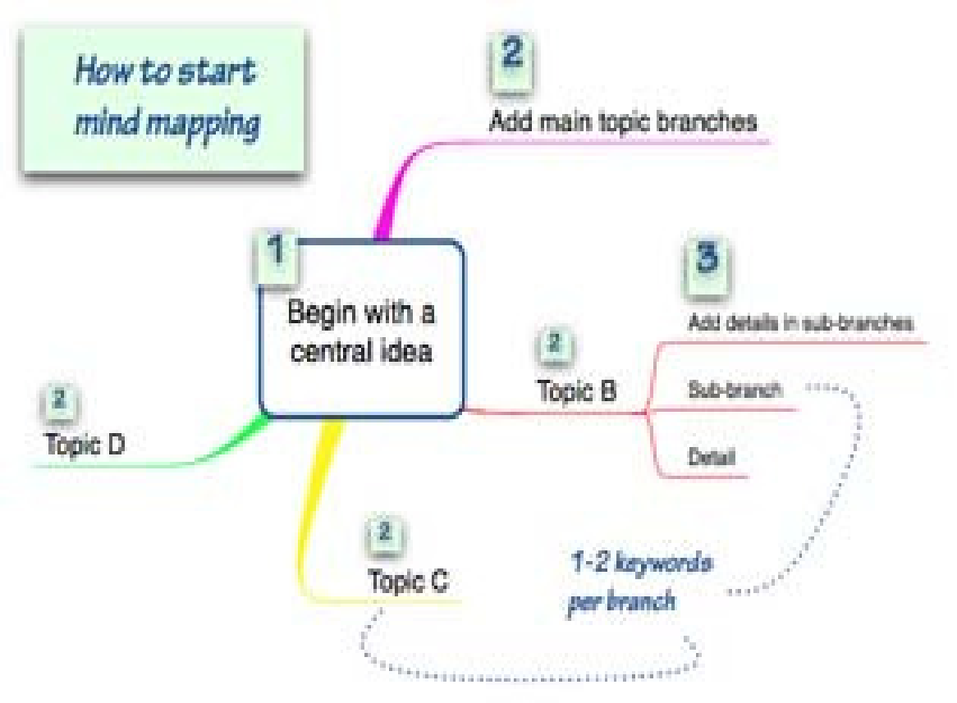
Mind Mapping is a way of creating pictures that show ideas in the same way that they are represented in your brain. Your brain uses words, pictures, numbers, logic, rhythm, color and special awareness to build up unique pictures of information. The ideas are linked together in a way that makes it easy to understand and remember.
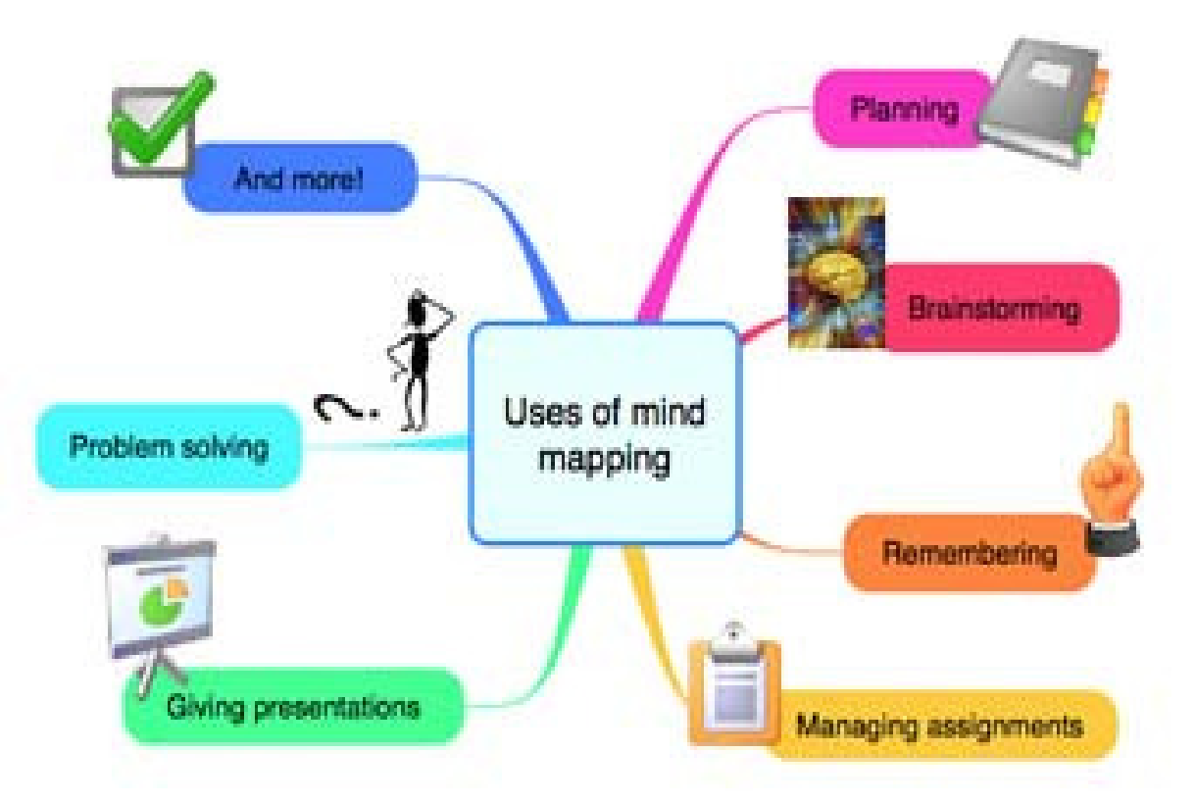
Mind Maps use exactly the same types of things to show the ideas and link them together. This is what makes Mind Mapping so powerful. You start with a central topic that you are going to be examining, and add branches radiating from the center, and then sub-branches as required to represent your ideas.
You create your Mind Maps in a natural way by using your own words and connections that make sense to you. It is best to stick to one or two keywords on the branches and use the branches to show the connections between the ideas. You can use Mind Maps for every part of your life where you need to:
♦ think more clearly; plan or organise things; solve problems; make
♦ decisions; remember things; do assignments; come up with new
♦ ideas or give presentations.
- Peer assessment
Is where learners are involved in the assessment of the work of other learners. Learners must have a clear understanding of what they are to look for in their peers' work.
- Self assessment
is a process where learners are involved in and are responsible for assessing their own piece of work. It encourages learners to become independent and can increase their motivation.
The assessment gains more value if the learner can see (in picture form or basic key words), how they have done.
3.4 Note taking
Note taking is the practice of writing pieces of information, often in an informal or unstructured manner Notes are frequently written in notebooks, though any available piece of paper can suffice in many circumstances.
Unfortunately, it is often the case that while students are busy taking notes, they do not pay sufficient attention to what the facilitator is actually saying or explaining. This fact justifies the use of handouts printed in advance and given out to each student. The flip side of this is that note taking makes learning "active learning" as opposed to "passive learning." When students have nothing to do but listen to the lecture, it is difficult for them to stay alert and attentive all of the time.
An easy solution to the problem is to figure out if you are an auditory learner. If you are, then it's probably better to listen and review with your textbook. If you are a visual learner, then the best would probably be a combination of listening and note taking. If you learn by writing then you should focus more on note taking.
Note taking from reading:
There are three main ways to take notes from written material.
♦ The first is direct quotation, in which the note taker copies a passage verbatim (using exactly the same words) from the original text. Normally the copied passage should be enclosed in quotation marks.
♦ The second method is paraphrasing. This involves a rephrasing of the information in the reader's own words, indicating that he or she has read and comprehended the information enough to restate it.
♦ The third method is summarizing. Summarizing involves not just rephrasing the information but condensing it to the essential meaning.
3.5 Memorising
There are many situations where we need to memorise facts and information. These include learning a foreign language, revising for an examination, giving a speech, as well as remembering simpler things like people's names and bank card PIN numbers. Fortunately there are many so-called mnemonic (memory aid) techniques available which can help us with these. You will probably be familiar with some of these techniques from your school days. For example, most of us are able to remember the colours of the rainbow by using a mnemonic such as…………….
'Richard of York gave battle in vain'. Here the initial letters of the seven words give us the colours: red, orange, yellow, green, blue, indigo and violet. This example demonstrates two elements of memorisation: imagination and association.
Thus you create a sentence (imagination) using words starting with the initial letters of the colours (association). Harry Lorayne says there are really only three fundamental learning skills:
- Locating the information you need.
- Remembering the information you locate.
- Understanding and organizing the information you've located and remembering, so you can apply it.
Memory works by association. In order for you to remember any new thing, it must be associated with something you already know or remember. As you learn and remember more, you give your memory more "hooks" to add further associations. By doing this, you will rapidly become a genius!
3.6 Key words
A keyword is a word or concept with special significance, in particular any word used as the key to a code or used in a reference work, to link to other words or other information.
3.7 Underlining
An underline, also called an underscore, is one or more horizontal lines immediately below a portion of writing. Single, and occasionally double ("double-underscore") underlining was originally used in hand-written or typewritten documents to emphasise text.
When underlining text, it often helps you to understand/remember better, if you underline things that belong together in the same colour. If there are different things in the same text, use different colours.
4. Ask relevant questions
'a form of words addressed to a person in order to elicit information or evoke a response'. This means to direct words to a person in such a way, that they (hopefully!) respond with the information that you require.
4.1 Reasons for asking questions
- The most common use is to get information. If you need to find out something, the best way to do so is to ask a question. The most important factor here is, however, to ask the correct person the correct question.
- If someone has given you information, you might want to check with them that you understood them correctly, or alternatively, if the information was not conveyed clearly, clarify the meaning of what has been said. In both cases, it is obvious that the end result will not be the desired one if the wrong 'message' is acted upon.
- In conjunction with the above paragraph, it is necessary to confirm the accuracy of the information. Inaccurate information will lead to the same end result.
- Often people are too afraid to ask a question, in case they 'look stupid'! It must be remembered, however, that more often than not, there are other people in the group who would also like to ask the same question, but are too afraid/ embarrassed to do so.
Remember: Rather ask a question and be a fool for five minutes, than not ask a question and be a fool for the rest of your life.
5. Texts are read/viewed for detail, interpreted and analyzed for a given context
When you read it is also for a purpose, even if the purpose is to pass time paging through a magazine. The difference between reading and listening to someone speaking to you is: when you read, you listen to the words someone is speaking to you on paper (written down), instead of listening to what they are saying to you in person. It is sometimes more difficult to interpret the written word, because you have to read for key words and key concepts. Purposeful preparation is very important if you want to give meaningful feedback.
First you plan: You extract key words and key concepts by underlining them. (Don’t underline full sentences. Key words refer to the nouns and the verbs in the sentence). Read chapter or module titles, section headings, sub-headings and paragraphs for key words. Make use of reading skills and techniques. It may be necessary to read more than one reference to find all the information you may be looking for.
♦ Then you prepare: Take time to rearrange and restructure the key ideas (keywords and key concepts) into sentences. Extend these sentences into paragraphs that you organise into a logical sequence to make your feedback meaningful. You have to rearrange the information you have gathered to make it your own, or to understand it.
Now only can you present feedback, or respond either verbally or in writing, in the correct format. Meaningful feedback is prepared:
♦ It is planned – key information has been collected
♦ All the key issues are sequenced logically
♦ They are organized and well structured
♦ The final task is presented accurately, in the correct format.
6. Reading techniques
When you extract key issues from a written text, you are in fact planning your response. But you must know your purpose for reading. You are brainstorming or gathering information with a specific purpose in mind:
- to find specific information
- to gain an overview of a topic
- to express an opinion
- to give accurate feedback
- an interest in the topic
- to use the information in a different context
- to link and integrate information
6.1 Reading for pleasure: when you read something for fun or out of interest and curiosity. Without realising it you learn a great deal when you read for pleasure.
6.2 Scanning: when you are looking for specific information (a name; a date; etc.), or for an answer to a particular question. Let your eyes “run down” the page with only one thought or question in mind, the other facts are of less importance. Read headings and subheadings. Focus on the key concept or the specific information you are looking for.
6.3 Skimming: to form an overview or a rough idea of the material you have to read. Skim through pages asking yourself questions, encouraging yourself to read with a purpose in mind. Focus on creating visual images of what you are reading. Ignore all unnecessary details and examples and concentrate on the required facts.
Take note of chapter headings, subheadings and the layout of pages, and decide whether it is necessary to read the whole chapter or only the relevant components. ♦ See if there is a summary at the end of the chapter. Read it first to create an initial mind picture of the contents of the chapter.
♦ Refer to the diagrams - if you are able to interpret them, you will have a better understanding of the text, and they will add detail to your initial mind picture.
♦ Read the first paragraph of each section or chapter, as it provides the clues or introduces the topics to be discussed. The first sentence of each paragraph usually introduces a topic or main idea. The conclusion is usually outlined in the last sentence of a paragraph, the last paragraph of a section and/or either the final chapter or last two chapters of a book.
6.4 Reading in detail: when information cannot be found during scanning or skimming, you have to read sentences and paragraphs more thoroughly. You make use of this technique when you are looking or reading for additional or supplementary information.
6.5 Reading critically: People are easily influenced by the opinions expressed by other people. It is important to remember that you are allowed to differ from the opinions of others. Perhaps your opinion is more acceptable and to the point. Thus it is important to be subjective when regarding the opinions of others.
Critical reading is also applicable when doing research on a specific topic. You will be required to read the findings and opinions of a number of people; you will not only learn from them, but you can add to their findings by expressing your own opinion. A typical example of critical reading, is the newspaper or even a magazine, where a point of view is explicitly (directly and clearly) expressed, e.g. by one newspaper editorial only, or implicitly (indirectly) expressed, e.g. various newspapers that give different interpretations of the same topics/issues/principles. Newspapers give people’s opinions. More than one paper per day means more than one opinion! Distinguish between fact (cannot be argued or changed) and opinion (can be changed or influenced), and then express your own point of view on the topic. You cannot express your own opinion if you do not have a clear understanding of the topic being critically examined!
7. Spoken input is listened to for detail, interpreted and analysed for a given context

Good listening
Nature gave man two ears but only one tongue, which is a gentle hint that he should listen more than he talks. Throughout every day, you are continuously part of different situations where you have to respond to thoughts, opinions, ideas, statements, etc. It is important that in every situation you listen, and put yourself in the other persons’ shoes before you respond. If you react impulsively, you could set up communication barriers, and interrupt the successful flow of communication.
7.1 The benefits of good listening are....
- Good listeners can make better decisions because they have more information.
- Good listeners save time because they learn more within a given period of time.
- Listening helps the communicators determine how well their messages are being received. Good listeners encourage and stimulate others into speaking.
- Good listening decreases misunderstanding.
Once again, it is of great importance to be aware of the speaker's possible bias, beliefs or incorrect/different perceptions that could have a negative impact on the listener. Biased information can lead the listener in a wrong direction, causing incorrect perceptions or understanding to be formed.
A biased speaker will lead the listener to extract a subjective implicit message, which is not necessarily the "truth", or "reality". Beliefs indicate a person's subjective attitude toward something. As a result of a belief, a speaker has great control over the message that is conveyed. If he/she has a positive attitude about something and believes that it is the correct thing to do, the listener will receive a positive message, and will subsequently be affected in a positive way.
When difficult or controversial matters are addressed, it would be wise to look into the possible bias and/or beliefs of the speaker, before a conclusion or decision is formulated.
8. Learning takes place through communicating with others in groups or as individuals
To learn means to gain knowledge of something, or to acquire skill in some art or practice. It also means to commit to memory (memorise). Learning is something we do our whole life - we continuously come across things we need to do/know that were previously unknown to us, thus forcing us to learn. Learning can also be a conscious decision, taken to improve your academic/technical qualification.
All learning does, however, take place in the same way. Let us look at a basic model:
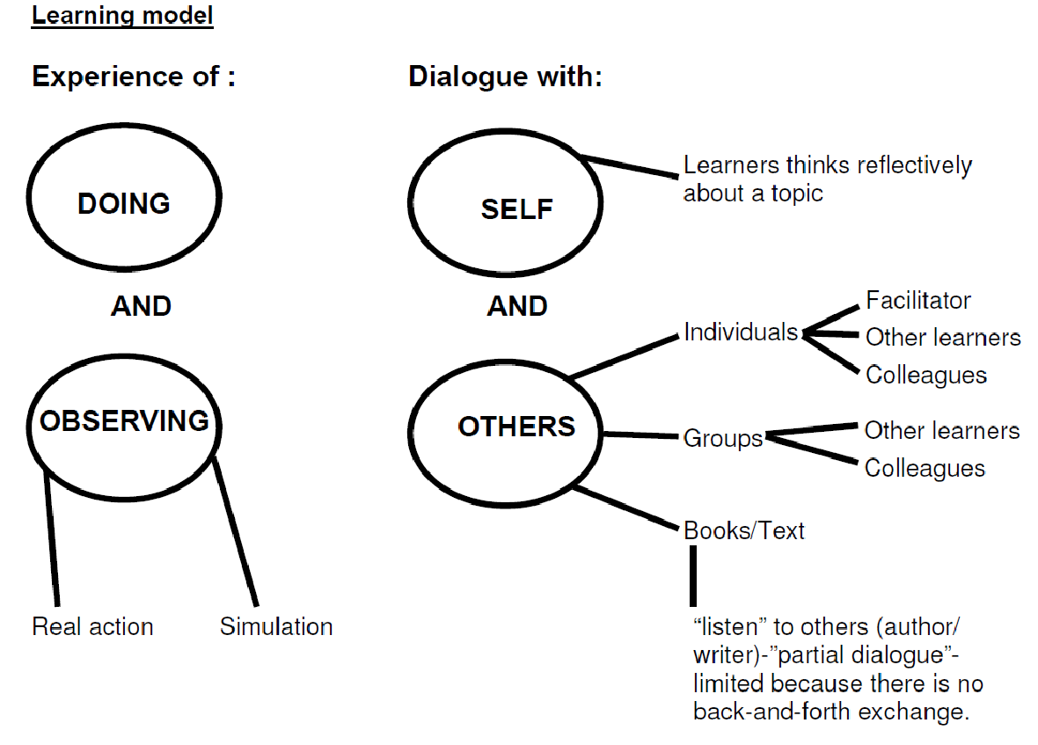

Let us look at the above model in detail:
You experience the 'doing' or 'observing' of what you want to learn. The observation could be of real (actual) action, or a simulation.
You enter into dialogue with:
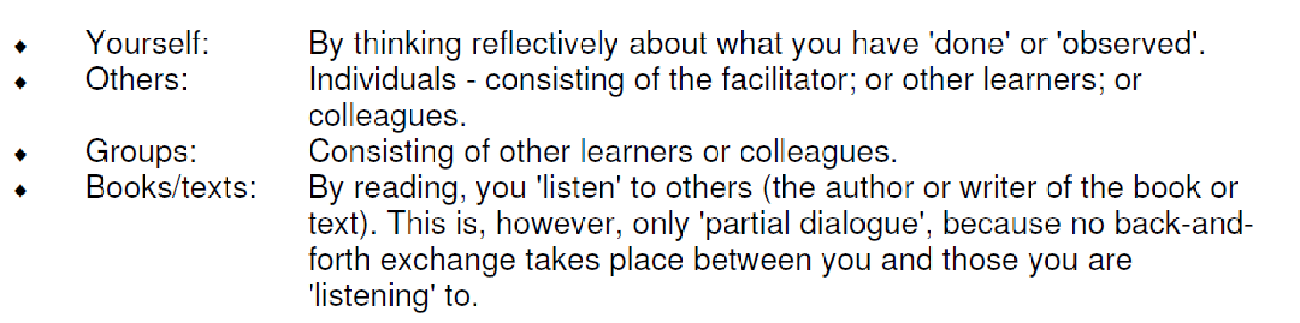
By communicating with others, be it individually or in groups, you are exposed to the opinions and perceptions of others, which often differ from your own, giving you the opportunity to change your mind. You are also able to confirm what you have learnt. Should you have misunderstood something, you can now correct it. It is a well-known fact that if your thoughts are verbalised (as they will be in a discussion with others), they tend to be remembered more easily.

SESSION 3.

MANAGE OCCUPATIONAL LEARNING MATERIALS.
Learning Outcomes
- Occupational learning materials are organized and used for optimum learning.
- Layout, presentation and organisational features of learning materials are understood and used effectively.
- Technical language/ terminology is engaged with and clarification sought if needed.

1. Introduction
Occupational learning materials are learning materials that apply to that specific occupation/trade/profession. They are very necessary when it comes to training or instructing the people working in that occupation, when trying to increase their proficiency levels.
It is, however, very important to use the vast array of learning materials appropriately - i.e. they must be managed correctly.
2. Organise occupational learning materials for efficient use
There is a wide range of learning materials available that make the training of workers less daunting than in the past. The learning materials at our disposal are:
♦ Texts
♦ Handouts
♦ text books
♦ Charts
♦ Maps
♦ Plans
♦ Diagrams
♦ videos/dvd's
♦ Internet
♦ models
These are probably the most widely used learning materials, because they are easily accessible, more affordable, 'portable' and usually user-friendly. They must, however, be used correctly.
It will be a futile exercise to use this learning material on illiterate workers, or where workers are trained on-site and have nowhere to put the books in order to read them or follow the facilitator. It is also important that the content is appropriate - the correct information at the correct level for the worker
2.2 Charts, maps plans, diagrams and models
It must be clear (easy to read/see) and also simple enough to understand, without losing importance. These are usually used to illustrate or explain a concept or an object. Once again, the circumstances must be conducive to using these, the end result will not be successful if they are used outside in the wind with nothing to hold them down.
2.3 Videos/Dvd's
These learning materials often succeed where others have failed. The reason for this is that most people learn best visually. Of great importance is that the videos/dvd's must be current, they must be of good quality (sound and picture clarity) and they must be appropriate. The equipment used to project the video/dvd must be of acceptable standard and in good working order. Lastly, the workers (recipients of the information) must be able to understand - must be on the same level as - the information.
2.4 Internet
This learning material is usually very current, but unfortunately, also very exclusive. In
most companies/organizations the majority of the workers are not computer literate, or
they do not have access to computers. The internet contains the most wonderful information,
presented in the most amazing way, but if it is not accessible, it is worthless.

2.3 Videos/Dvd's
These learning materials often succeed where others have failed. The reason for this is
that most people learn best visually. Of great importance is that the videos/dvd's must be current, they must be of good quality (sound and picture clarity) and they must be appropriate.
The equipment used to project the video/dvd must be of acceptable standard and
in good working order. Lastly, the workers (recipients of the information) must be able to
understand - must be on the same level as - the information.

2.4 Internet
This learning material is usually very current, but unfortunately, also very exclusive. In most companies/organizations the majority of the workers are not computer literate, or they do not have access to computers. The internet contains the most wonderful information, presented in the most amazing way, but if it is not accessible, it is worthless you have now seen how very important it is to organize your learning materials carefully and to use them efficiently, in order for learning to take place successfully.
3. Layout and presentation of learning materials are understood and used effectively
Most learning materials are set out and presented in an organised way, to assist the learner to extract the necessary information. It is important that the learner understands and uses the layout
♦ Contents page: This is the page at the beginning of the document/book that lists everything contained in chronological order - i.e. in the order it is presented. It also lists the page number on which it can be found. The contents page enables us to go straight to the necessary information, without having to page through the whole document/book.
This page also enables us to ascertain whether the information included is appropriate to our need/purpose. The contents page is very valuable when it comes to time management.
Glossaries: This is an alphabetical list of terms particular to a field of knowledge, with explanations. It helps us to understand terms found in the text that are unfamiliar to us. Because those terms are specific to a topic/subject, they are often not found in the average dictionary. The glossary can be found at the back of the book/ document, just before the index.
♦ Index: This is an alphabetical list of persons, subjects, etc., mentioned in a printed work/text, usually at the back, and indicating where they are referred to. This list helps us to go to the exact place in the text where what we are looking for, is located.
♦ Electronic texts: These are texts (written work/information) found on computers as email or internet websites. The layout and presentation of these texts differs greatly, for various reasons.
Firstly, because the information gets updated regularly, the contents page, glossary and index change continuously - this sometimes leads to writers disregarding those three items in favour of a more informal layout.
Secondly, the fierce competition amongst various websites results in many individual layouts and presentations, to attract the most attention. In order to extract the optimum information from an electronic text, a person has to be very familiar with the computer and its various functions.
4. Technical language/terminology (jargon) is engaged with, and clarification sought if needed
Technical language or terminology is specific to an occupation/trade/ profession, therefore you will come across it in your work. It is important that you familiarize yourself with it, as it will accelerate your progress and benefit you in the long run. The first place to seek clarification is in the glossary of the text you are dealing with. Alternatively, colleagues or your superiors should be able to assist you.
From the above information it is clear that it is vital to manage occupational learning materials well, in order to achieve your goals.

SESSION 4.

CONDUCT RESEARCH AND ANALYSE AND PRESENT FINDINGS
Learning Outcomes
- Appropriate or relevant topic and scope is identified and defined.
- Research steps are planned and sequenced appropriately.
- Research techniques are applied.
- Information is sifted for relevance.
- Information is classified, categorised and sorted.
- Research findings are analysed and presented in the appropriate format.
- Conclusions and recommendations are made in the appropriate format.

1. Introduction
In order to complete this learning unit successfully, it is important to know the following definitions:
Research: Systematic investigation to establish facts or collect information on a subject.
♦ Analyse: To examine in detail and break down into components in order to discover meaning, essential features, etc.
♦ Define: To state precisely the meaning of words, terms, etc.
♦ Present: To submit for judgment or consideration
♦ Findings: The conclusions reached after analysis

2. Appropriate or relevant topic and scope is identified and defined
When conducting basic research, it is vital to identify a topic that covers the required area that will enable you to complete the task successfully.

EXAMPLE
When researching the hosting of the Olympic Games, it will be meaningless to look into the education system of our country, but of great value to look into the types of accommodation that are available.
From there it will be necessary to define accommodation, in order to satisfy the needs of the target market.

3. Research steps are planned and sequenced appropriately
When starting with your research, it is very important to have a plan of what you need to do, otherwise you will end up with a mountain of information that confuses you and has very little value as to achieving your goal. It is also necessary to sequence the information so that it makes sense.
All this can only happen if your research steps are planned and sequenced:
3.1 Task Definition
♦ define the topic/problem
♦ identify the information requirements of the topic/problem
3.2 Information Seeking Strategies
♦ determine the range of possible sources
♦ evaluate the different possible sources to determine priorities
3.3 Location and Access
♦ locate sources
♦ find information within the sources
3.4 Use of Information
♦ engage (read, hear, view, touch) the information in the source
♦ extract information from a source
3.5 Synthesis: - Putting it all together
♦ organise information from multiple sources
♦ create a product or performance
3.6 Evaluation
♦ judge the product or performance
♦ judge the information-solving process
4. Research techniques are applied
The research techniques are how we go about gathering the necessary and appropriate information.
♦ Reading/viewing: You will have to physically read or view the sources you have located. Write down or photocopy the relevant information that you will be able to use in your final product or performance.
♦ Interviewing: A wealth of information is to be gained from other people. This can be done by interviewing them orally, or by having them complete questionnaires. In both cases, only use the relevant information acquired.
♦ Observing: There are times when you just have to see how things are done in order to get the necessary information. It is very important to make sure that who or what you are observing, is 'behaving' correctly/appropriately.
♦ Using appropriate electronic sources: As mentioned earlier, electronic texts are wonderful sources of a wide variety of information. It is, however, of great importance to select them carefully, making sure that the information contained is appropriate.
5. Information is evaluated for relevance
In order to evaluate the relevance of the information you have gathered, you need to ask questions. You need to ask questions, that have as answers, the keywords used in the identification of the information requirements. If you have managed this successfully, then you can be sure that the information is relevant.
6. Information is classified, categorized and sorted
To classify is the act of distribution into groups, according to some common relations or attributes.
To catergorise is to place into or assign to a category (a group, often named or numbered, to which items are assigned based on similarity or defined criteria). To sort is to arrange according to class, type, etc.
Even though these three definitions are very similar and one wonders what the difference is, it will be of great value to classify, categorise and sort the information you have gathered.
When you classify the information, you take individual concepts and group them with other similar concepts. When you categorise the information, you take those classified groups and put them into bigger groups that are named and numbered. This will assist you in your placement of the information in the correct sequence.
When you sort the information, you place the categories into the correct order or sequence. After you have classified, categorised and sorted the information, it should make sense and be user-friendly, resulting in a good product, presentation or performance.
7. Research findings must be analyzed and presented in the appropriate format
Analyse: To examine in detail and break down into components in order to discover meaning, essential features, etc. It is important to analyse the research information you have collected, in order for you to be certain that you are addressing the correct topic/problem. This can only happen if you understand the information.
Once the information has been analysed and you are sure that it is relevant to your presentation, you must present it in the appropriate format. These are a few examples of presentation formats:
EXAMPLE
♦ Advertisement
♦ Article
♦ Flip chart
♦ Poster
♦ Brochure
♦ Slide show (PowerPoint)
♦ Oral report/presentation - (discussed in detail below)
8. Oral Presentation Format
8.1 Preliminary analysis and planning of your oral presentation:
Questions to ask yourself:
♦ Why am I speaking on this subject (problem)?
♦ To whom am I speaking (lay person, executive, expert)?
♦ What does the listener (audience) want or need to know?
♦ Am I supposed to offer a solution to the problem?
♦ Do I expect the listener to take any action? If so, what action?
♦ Do I want questions, suggestions or comments from the audience?
♦ What is the purpose of my presentation?
⇒ to communicate information?
⇒ to motivate my audience to accept my conclusions and recommendations?
⇒ to stimulate them to take action?
Gathering and organising information:
♦ Use card catalogues, indices, reference stations, etc.
♦ Read and take notes on relevant information
♦ Develop a working outline, group information by category
♦ Read more articles than you use
Composing the oral presentation:
♦ Introduction: states the idea of your presentation
⇒ Capture the attention of your audience
∗ First few sentences must interest your listeners
∗ Humour - can help, but can also be dangerous
∗ Begin with a visual aid or sound effect
⇒ Introduce subject of your report
∗ Clearly state objectives
⇒ Establish your credibility for your conclusions and thesis
♦ Body: develops the idea
⇒ Explain subject in detail to accomplish the objectives of your presentation
⇒ Methods for developing the body
∗ Examples illustrating points (visuals)
∗ Repetition of the major points
∗ Statistics sparingly used, and projected as visuals
∗ Comparisons and contrasts to touch the experience of the audience
∗ State expert source of subject
♦ Conclusion: reinstates and reinforces the idea
⇒ The last thing you say is as important as the first in which you gained your audience's attention
⇒ Deliver the 'payload'
∗ Review the purpose (objectives) of your presentation
∗ Summarise and underscore (stress/reinforce) the main points
∗ Make a conclusion from those points
⇒ Keep short and to the point
♦ Practicing the delivery:
⇒ "Practice makes perfect"
⇒ Rehearse as closely to the actual speech situation as possible.
∗ Practice standing up
∗ Practice holding your notes
∗ Practice using visual aids
∗ Practice in room that you're giving presentation in or imagine it
∗ Practice in front of friends, in tape recorder or in front of mirror
♦ Delivering the oral presentation:
⇒ Breathing
∗ Take a big breath before you start, breathe often during presentation
⇒ Pitch
∗ Voice inflection (change in tone, pitch and volume) makes presentation more interesting
Voice quality
∗ Resonance (amplification) adds richness to sound
⇒ Intensity
∗ Be loud enough for everyone to hear, speak slightly louder than conversation
⇒ Rate
∗ Speaking too fast or too slow will irritate and lose your audience
⇒ Pause
∗ Pauses draw attention to important points and help in breathing
⇒ Pronunciation
∗ Make sure you pronounce words correctly
⇒ Enunciation
∗ Speak clearly, distinctly and precisely
⇒ Body language
∗ Try to appear self-confident and relaxed
∗ Eye contact is very important
∗ Avoid distracting gestures: scratching, excessive walking, etc.
⇒ Visual aids (see below)
♦ Visual aids:
⇒ Function
∗ Keep audience interested
∗ Present information in clear fashion
∗ Help audience retain information
⇒ Types of visual aids
∗ Models
∗ Graphs
∗ Maps
∗ Charts
∗ Photos
∗ Drawings
∗ short printed passages
⇒ Keep simple and readable
⇒ Explain in detail
IMPORTANT
As can be seen from the above detailed format, it is very important
to:
♦ Know what the exact purpose of the presentation is
♦ Know who you are presenting to
♦ How what you are going to say
♦ Know where you will be presenting
♦ Know what you will need for the presentation
♦ Know how much time you have - don't go over the time

SESSION 5.

LEAD AND FUNCTION IN A TEAM.
Learning Outcomes
- Active leading and participation takes place in group learning situations.
- Responsibilities in the team are taken up and group work conventions are applied in learning situations.
- Conflict management and negotiating techniques are practised in diverse contexts.
- Team work results in meaningful products, outcomes or goals.

1. Introduction
In life, a good team has a better chance of getting to the top (achieving goals) than an individual has. It is therefore of great importance to be able to function well in a team (group). The aim of group work is to produce better (more effective, more detailed, more comprehensive) presentations and reports. This is achieved through the combined talents of group members, contributing knowledge and ideas.
One difficulty with group work is that you can't work as quickly as you can by yourself. Patience, communication skills and commitment are all required to make the most of the contributions of all group members. Thus, effective group work requires each member to focus on the process rather than just the product.
2. Active participation
Active participation must take place in group learning situations
2.1 Meetings
In a meeting, two or more people come together for the purpose of discussing a (usually) predetermined topic, such as business or community event planning, often in a formal setting.
In organizations, meetings are an important vehicle for, and personal contact with, human communication.
The reason for holding a meeting will determine what kind of meeting will be necessary:
EXAMPLE
♦ Status Meetings: Generally Leader-led, which are about reporting by one-way communication;
♦ Work Meetings: Which produce a product or intangible result such as a decision
♦ Staff meeting: Typically a meeting between a manager and those that report to the manager (possibly indirectly).
♦ Team meeting: A meeting among colleagues working on various aspects of a team project.
♦ Ad-hoc meeting: A meeting called together for a special purpose
♦ Management meeting: A meeting among managers
♦ Board meeting: A meeting of the Board of directors of an organization
♦ One to one meeting: A meeting between two individuals

It is very important to make use of communication opportunities, especially as those afforded at meetings, should you need to make a point, clarify your understanding, share information, etc. In order to do this, you need to participate actively, i.e. you need to play a constructive role in the meeting. Not only will you be imparting information, but you should learn (from various people) as well.
Site visits are planned and organised well in advance. They usually accommodate groups, to minimize disruption.
Site visits allow for:
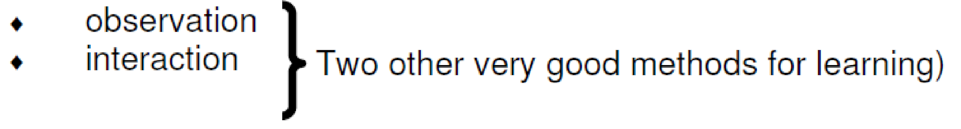

Once again, it is important to use the opportunities to learn, by participating actively while on the site/field visit.
2.3 Excursions
An excursion is a trip by a group of people, usually made for leisure or educational purposes. It usually takes longer than a site/field visit, but is less interactive. It consists mainly of observation. Excursions are, however, valuable learning tools, because one learns from the views and observations of other people.
An excursion is a trip by a group of people, usually made for leisure or educational purposes.
2.4 Discussions
A discussion is the examination of a matter in speech or writing. Here we are looking at a discussion in speech, more specifically a group discussion. As already stated, it is the examination of a matter, i.e. to investigate or discover facts about the matter. When this is done in a group, each member will give their own opinion and findings, thus disclosing varied points of view, from which one can learn. Active participation in the discussion is necessary for learning to take place.
2.5 Activities
This is the participation in specific tasks - often to practice a new skill or knowledge. When this is done in a group, it gives you the opportunity to differentiate between positive and negative outcomes, thus affording more learning opportunities, provided you participate actively.
2.6 Workshops
A workshop is a gathering or training session which may be one day (or part thereof) or several days in length. It emphasizes problem-solving, hands-on training, and requires the involvement of the participants. Often a symposium, lecture or meeting can become a workshop when it is accompanied by a practical demonstration. Once again, this is an ideal opportunity to learn from others, be it facilitators or peers.
3. Responsibilities in the team
As mentioned earlier, group work has its problems, one of them being unfair distribution of work and/or effort. It is therefore vital that all the members take turns and that the roles/responsibilities are rotated within the group.
It can be very frustrating in a group where one, or a few members, do all the work, leaving the rest as onlookers who do not get the opportunity to do their share. Equally frustrating is when one, or a few of the members, shirk their responsibility and choose to be 'passengers', leaving all the work to the rest of the group. In a test or examination situation all the group members receive the same marks, which ends up being very unfair.
The three main roles which need to be rotated are:
♦ Conducting/chairing: This person leads or controls the meeting or group work situation. This is a very important role, as it can determine the outcome.
♦ Recording: This is an important role for two main reasons. Firstly, the recording has to be correct, because it is often referred back to for various reasons. Secondly, it forces the recorder to listen and concentrate, understand and then reproduce the information.
♦ Reporting: The reporter has to be able to relay the message/information in such a way that the listeners get all the necessary details, without having everything repeated.
Taking turns and the rotation of the above roles gives everyone in the group equal learning opportunities.
4. Conflict management and negotiating techniques
Conflict exists when there is a disagreement between two or more people because their perceptions of a situation are not the same. Many people feel that conflict must be avoided because it causes anger situations, but it does not only have negative or dysfunctional results. Conflict can also give rise to very positive or functional results. It is, however, very important that conflict is managed well in a defined context.
There is no one best way to deal with conflict. It depends on the current situation. Here are the major ways that people use to deal with conflict:
♦ Avoid it: Pretend it is not there or ignore it.
⇒ Use it when it simply is not worth the effort to argue. Usually this approach tends to worsen the conflict over time.
♦ Accommodate it: Give in to others, sometimes to the extent that you compromise yourself.
⇒ Use this approach very sparingly and infrequently, for example in situations when you know that you will have another, more useful, approach in the very near future. Usually this approach tends to worsen the conflict over time, and causes conflicts within yourself.
♦ Competing: Work to get your way, rather than clarifying and addressing the issue. Competitors love accommodators.
⇒ Use when you have a very strong conviction about your position.
♦ Compromising: Mutual give-and-take.
⇒ Use when the goal is to get past the issue and move on.
♦ Collaborating: Focus on working together.
⇒ Use when the goal is to meet as many current needs as possible by using mutual resources. This approach sometimes raises new mutual needs. Use when the goal is to cultivate ownership and commitment. Closely linked to conflict, we find negotiations. Negotiations happen all the time in our lives. We all want our own way, but the person or people we are with also want their own way - so you negotiate. To get what you want, you always have to do something in return, or give up something.
"If I come shopping with you now, I'm watching soccer this afternoon." "If I work over Christmas, can I have Easter off?" At work negotiations are sometimes more serious and are generally entered into with the specific intention of bringing about a change in a situation - e.g. negotiating for higher wages or different work conditions.
Both parties generally have a very strong reason for wanting the situation to change or to stay the same - depending on which side they are on. The ideal result of negotiations should be a win-win situation, where although people have had to compromise, neither side feels that they have given up too much and gained too little.
To negotiate successfully requires equal amounts of skill, common sense and compromise. Negotiations must be facilitated (led) by an unbiased chairman who does not stand to gain anything from the outcome. The chairman must be able to see all party's points of view and constantly seek the middle ground.
4.1 Guidelines that should make the negotiation process less stressful and more successful:
♦ Don't go into negotiations angry or aggressive. You will not be negotiating wisely and by antagonizing the other party/ies, you can actually do your own position harm.
♦ Know what you want to gain and what you are prepared to give up.
♦ Allow the other person to speak and listen to what they are saying. They too have their own needs and desires.
♦ Have a notebook with you so that you can write down points to remember. You might become so obsessed with having your say, that you will not be listening and could easily miss something important.
♦ If the negotiations are planned and everyone is given warning, prepare your case. The better prepared you are, the stronger your case will be. You will feel more in control and you will be more likely to get what you want. If necessary, seek advise from the experts.
♦ Depending on the situation, you might want to consult someone who knows the law or bookkeeping or whatever.
♦ Don't makes accusations or be insulting.
♦ Don't lose your temper. If you lose your temper, you give the other party power over you.
♦ If several of you are involved in the negotiations, you must choose a spokesperson who will do most of the talking. If it is wage negotiations, it could be your union representative.
♦ Before the negotiations take place, you must all meet to make sure that you share the same vision and want to achieve the same goal. You have to place your trust in your spokesperson, so choose them wisely.
5. Teamwork results in a meaningful product or outcomes
All work is always done with a goal in mind. The purpose of the activities that get done is to achieve that initial goal. Often the goal is nearly achieved, but not quite. This results in frustration and often despondency.
More often than not, the negative situation could have been avoided. Two key factors are:
♦ Reaching consensus: To reach consensus means to reach general agreement (within the team). It is vital that the whole team is in agreement (even if negotiation has had to take place to bring it about), in order for the goal to be achieved. If there is no consensus, it means that the team members have different goals. If you do not agree with something, it is very difficult to give your commitment. This will ultimately sink the team as far as the original goal goes. Remember, a strong team is a united team!
♦ Task completion: In soccer we sometimes say a team can't 'finish', or their 'finishing skills' are poor, when they get the ball within shooting range of the goal posts, but fail to shoot a goal. The whole team has worked very hard, but they go away empty-handed.
So often a team works diligently and hard to achieve their goal, but right at the end it all falls flat, because a small detail or issue was left out. This can be the result of all the members of the team not reaching consensus. A team that is in agreement will be eager to achieve success, and will see to it that everything necessary is done in order to do so.

SESSION 6.

REFLECT ON HOW CHARACTERISTICS OF THE WORKPLACE AND OCCUPATIONAL CONTEXT AFFECT LEARNING.
Learning Outcomes
- Sector and organisation type is identified.
- Features of the occupational environment are described and discussed.
- Ways in which these features affect learning processes and/or application of learning are described and discussed.

1. Introduction
Where you work (environment) and what type of work you do has an enormous influence on how receptive you are to learning. Some background knowledge on these obstacles can help you overcome them:
2. Sector and organisation type is identified
The economy of a country is divided into different parts called sectors. These sectors are made up of different types of organisitions that all have the same focus area, i.e. they all do the same type of jobs or offer the same type of services. Let us look at some of the sector focuses:
♦ Services
The services sector of industry involves the provision of services to businesses as well as final consumers. Services may involve the transport, distribution and sale of goods from producer to a consumer as may happen in wholesaling and retailing, or may involve the provision of a service, such as in pest control or entertainment. However, the focus is on people interacting with people and serving the customer rather than transforming physical goods.
♦ Manufacturing
The manufacturing sector uses tools and labour to make things for use or sale. It ranges from handicraft to high tech, but is most commonly applied to industrial production, in which raw materials are transformed into finished goods on a large scale.
♦ Construction
The construction sector consists of the following areas:
⇒ infrastructure, repair and maintenance;
⇒ public and private housing;
⇒ non-residential public property (e.g. hospitals and schools);
⇒ industrial (e.g. factories and processing plant) and commercial construction.
♦ Farming
South Africa is divided into a number of farming regions according to climate, natural vegetation, soil type and farming practices. Agricultural activities range from intensive crop production and mixed farming in winter rainfall and high summer rainfall areas, to cattle ranching in the bushveld and sheep farming in more arid regions. These agricultural activities are:
⇒ FIELD CROPS AND HORTICULTURE: Grain and oilseeds, sugar, fruit, wine, vegetables, cotton, tobacco, tea and ornamental plants and cut flowers.
⇒ LIVESTOCK FARMING: Dairy farming, beef farming, sheep and goat farming, poultry and pig farming, game farming and aquaculture (mussels, trout, tilapia, catfish, oysters and waterblommetjies (Cape pondweed) are the major aquaculture species)
♦ Transport
The transport sector consists of the following areas:
⇒ Road transport
⇒ Rail transport
⇒ Air transport
⇒ Sea transport
♦ Mining
The mining sector involves all industries that extract raw materials (e.g. coal, ores, etc.) from the earth.
♦ Educational
This sector consists of:
⇒ Schools (government and private)
⇒ Colleges
⇒ Universities
⇒ Training centres
⇒ Distance learning centres
♦ Government
The government sector is also called the public sector because it is representative of the public. It is made up of three smaller sectors:
⇒ National Government: National Government's responsibilities are everything to do with the whole country, e.g. defence, safety and security (police), health and welfare, finance, etc.
⇒ Provincial Government: Provincial Government's responsibilities are everything to do with the nine provinces, e.g. provincial roads, provincial safety and security, education, etc.
⇒ Local Government: Local Government's responsibilities are everything to do with the metro councils and municipalities, e.g. electricity supply, water supply, waste management, etc.
Within these various sectors, we find different types of organizations, e.g.:
EXAMPLE
♦ Government organizations: These organisations have only one shareholder - the government. Examples are: National Sporting Federations, Eskom, Nelson Mandela Children's Fund, etc.
♦ Parastatal Organisations: These organisations are partially state-owned. Examples are: Telkom, ACSA (Airports Company South Africa), etc.
♦ Heavy/Light Industry: These organisations are usually privately owned and listed on the stock exchange. Examples are: Mittal Steel, SASOL, PPC Cement, etc.
♦ Large Organisations: These organisations are privately owned and listed on the stock exchange. Examples are: Pick 'n Pay, Media24, etc.
♦ Small Business: These businesses are privately owned and seldom listed on the stock exchange. Examples are: Mr Video, your local butcher, your local spaza shop, etc.

3. Features of the occupational environment
The features of the occupational environment consist of everything that makes up that environment - physical and psychological. The physical features are always the easiest to identify and discuss, because they are tangible (can be seen and touched).
EXAMPLE
♦ Mining: Large machinery and equipment, lots of dirt
and residue, seldom spacious (inside the mine), etc.
♦ Heavy industry: Noisy, large machinery and equipment,
sometimes exposed to weather conditions, often
dirty, chemicals, etc.
♦ Large organizations: Sometimes hi-tech but impersonal,
lots of goods being moved around, people traffic,
etc.
♦ Small business: Limited resources, limited space,
temporary labour, etc.

The psychological features are not always easy to identify because they are not tangible. The different perceptions of people also make psychological features difficult to generalise (they do not always apply to everyone).
EXAMPLE
♦ Personality clashes
♦ Competitiveness
♦ Work
♦ Pressure, etc.

4. Ways in which occupational environment features affect learning processes and/or application of learning.
The environment in which one learns plays a very big role in how much learning actually takes place.
EXAMPLE
As an example, think of trying to learn in a factory, where the machines are making a lot of noise, the workers are shouting in order to be heard and a siren is sounding to signal that shutdown is five minutes away. There are so many distractions and obstacles that will prevent learning from taking place, even though the worker has the best intentions.
♦ Think of a worker trying to learn how to take stock during the annual stock-take. The environment will be a hive of activity, with noise and lots of movement interrupting his/her concentration. This situation will frustrate the 'teacher' as well as the 'learner', resulting in a negative experience for the worker.
♦ A final example is of workers attending a course at a training centre. There they get to sit at a desk in a quiet classroom and pay uninterrupted attention to the facilitator. Should they require assistance, it is available immediately.

